1. There are may be many environments (development, production, QA etc).

For each environment, there may be a specific properties file.  
So this is called profile.

1. **Agenda**:
   1. How to store separate configuration for limits service for these 4 environments.
   2. How do you make use of it from Spring Cloud Config Server?
2. Let’s see first how to store multiple environment configurations for a service in a git repo?
   1. 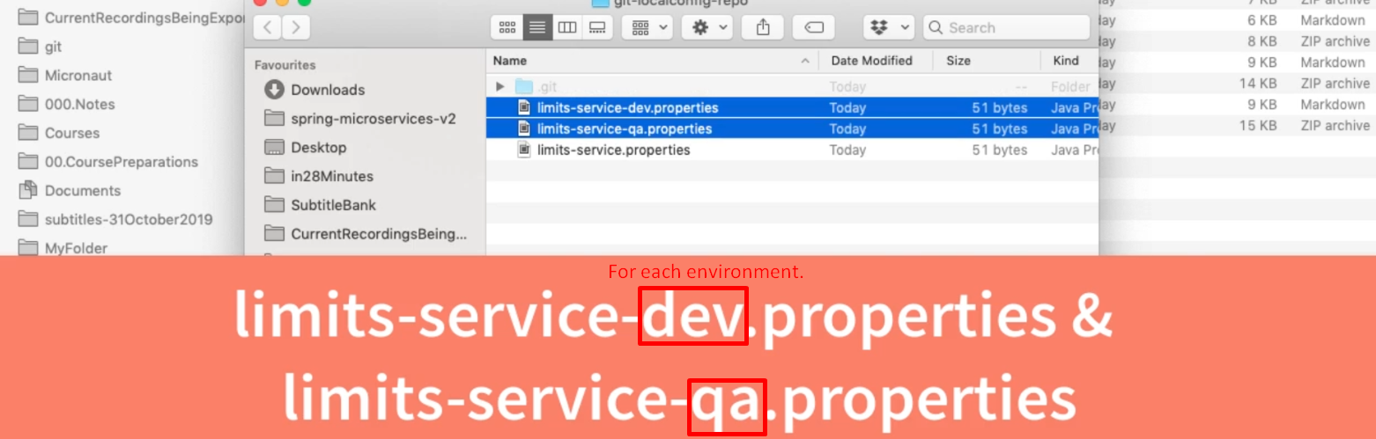
   2. 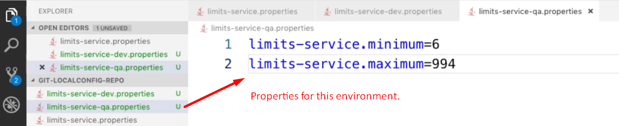
   3. 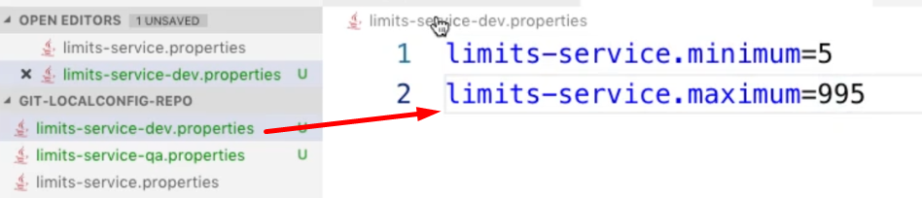
   4. 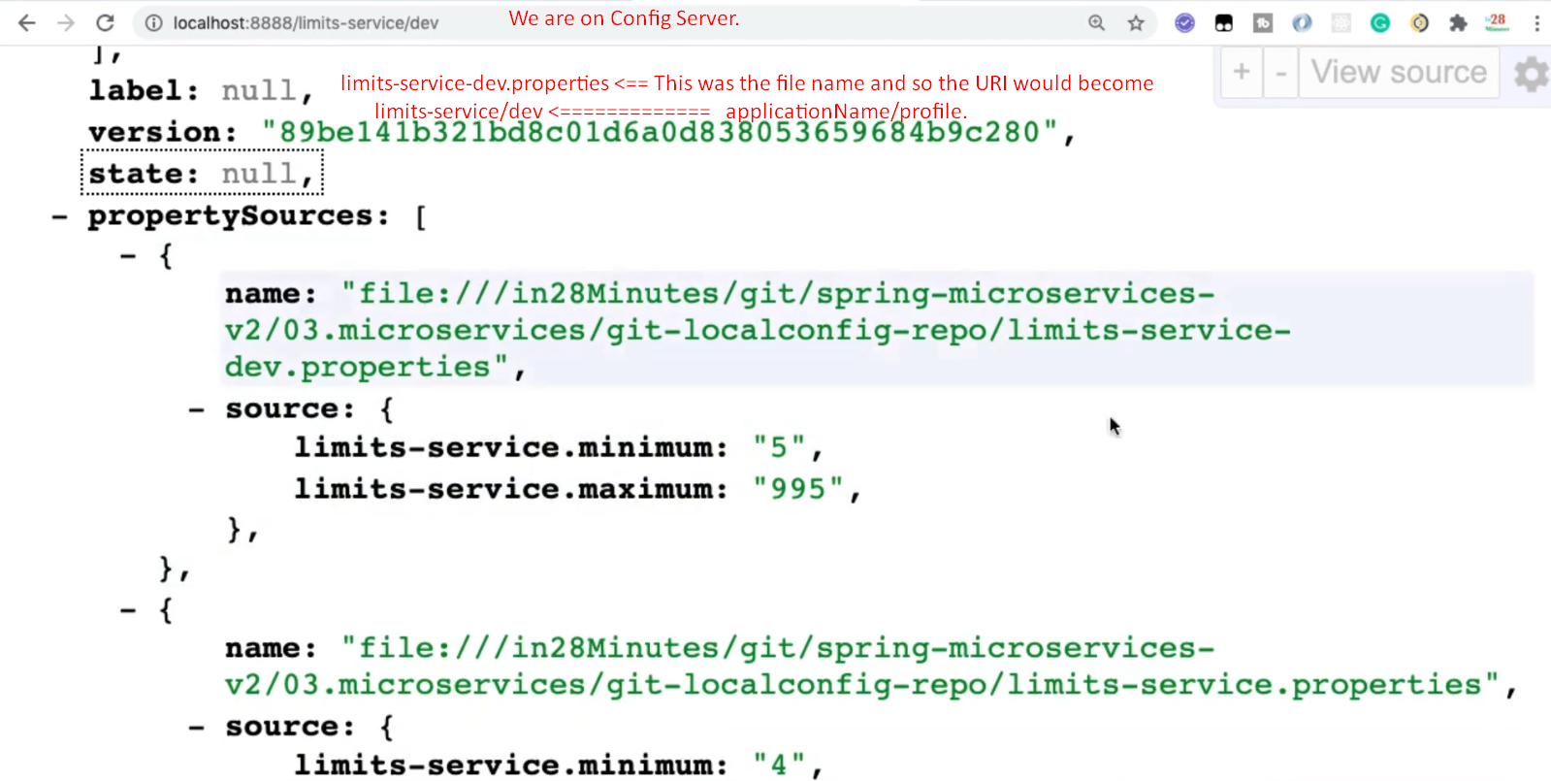  
      In the above slide, note that even though we are asking for properties file for dev but in the JSON is also returning default properties file too what the values in the specific profile (in this case dev) would have higher priority and the default properties file’s value would be replaced by dev properties file’s values.
3. 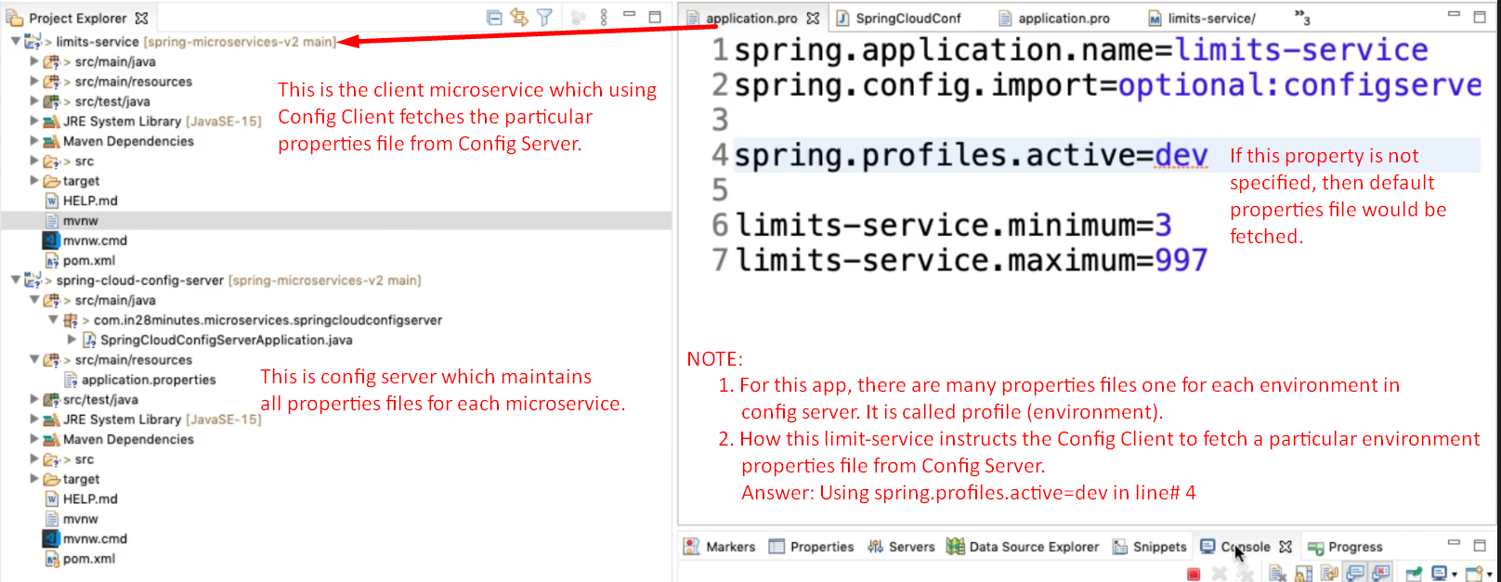
4. 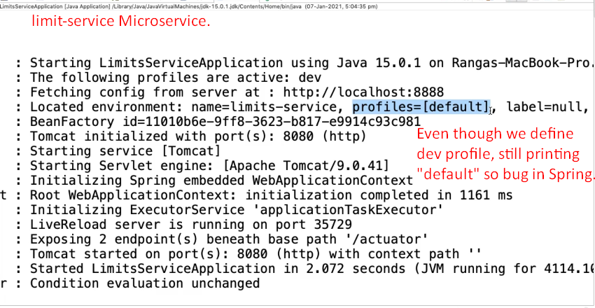
5. 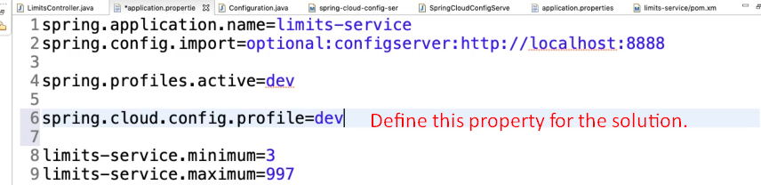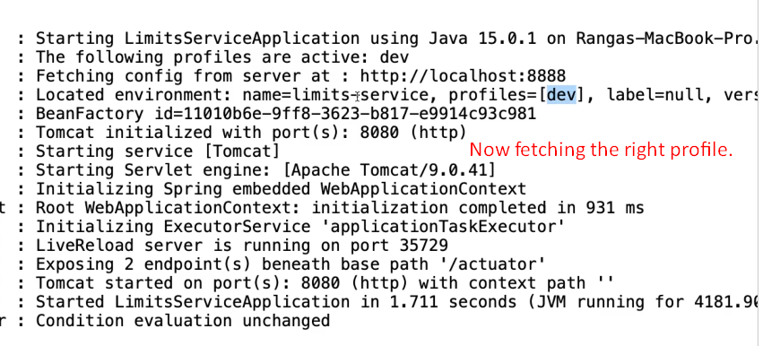
6. 